SAFEGUARDING OUR CHILDREN
(Child Protection)
If a parent has concerns about his or her child or another child’s safety, they may take the following action.
I have a concern about my child’s/ another child’s safety
Mrs Davidson
I can talk to the CLASS TEACHER

If I am still concerned I can talk to the Designated Teacher for Child Protection, Mrs Davidson

Or the Deputy Designated Teacher, Mrs Kelly
Anite Cheadle
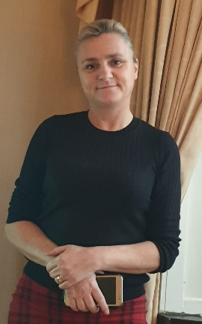

If I am still concerned, I can talk/write to the Chairperson of the Board of Governors, Anite Cheadle

Mrs Kelly

At any time, I can talk to the Child Protection Support Service (CPSS) from Monday – Friday 9am to 5pm on 028 95985590
or out of hours emergency 028 9504999
or
the Police Non-Emergency 101
Parents have access to the School’s Child Protection Policy which is available on our school website or from the school secretary.

