Working hard at home to complete my schoolwork is the right thing to do. This will make my teachers and parents/carers (delete as appropriate) happy.

**Learning from Home**

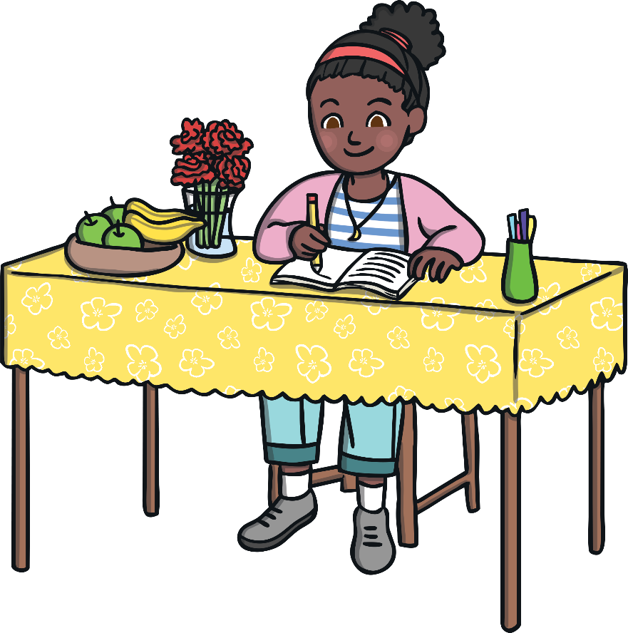





At the moment, the school I go to is shut. This is to keep me, my friends, my teachers and my family safe. This is OK.

My name is .

My teacher is .

I am years old.

I go to School.

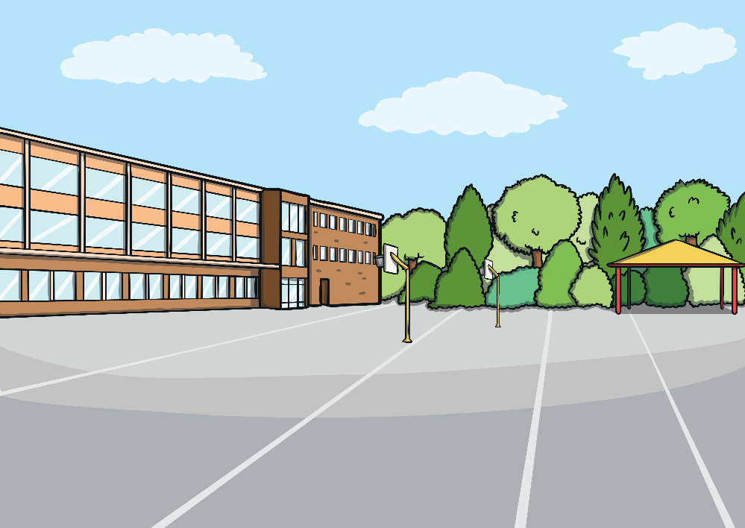



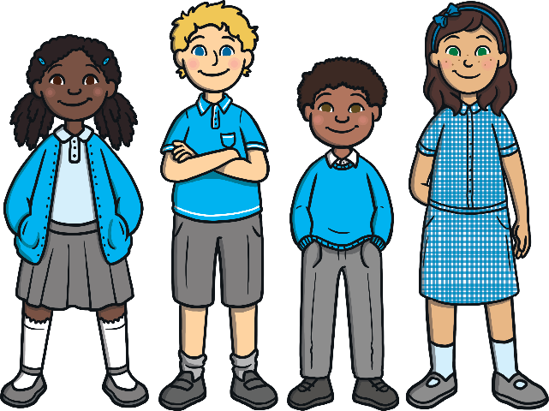

My teachers have set me work to do, at home. This will help me when the schools open again. My . (enter name of who is going to help the child at home) will help me to complete the set work. The work set could be completing worksheets or completing tasks on   
the computer.

On Monday, Tuesday, Wednesday, Thursday and Friday, I will do my schoolwork at home. All my friends will also be working from home.

This is OK.

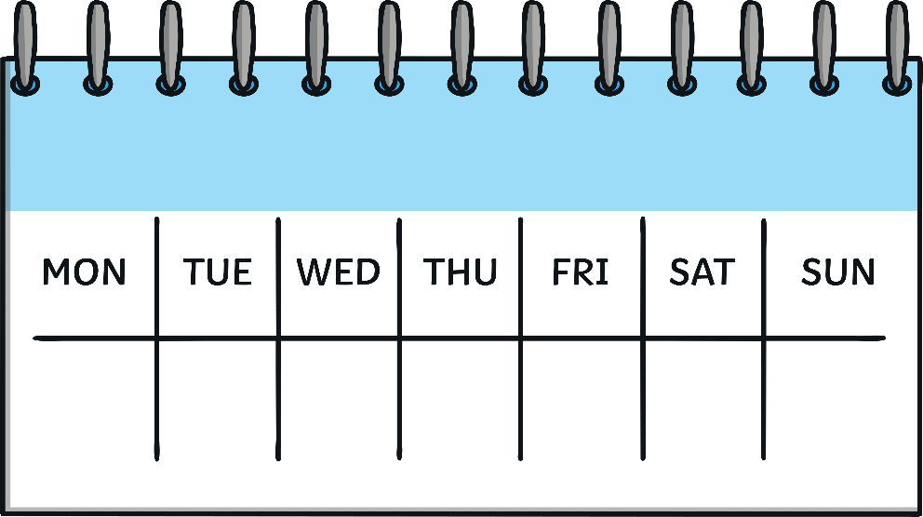





After I have finished my schoolwork, I can choose what I would like to do such as watch television, read a book, play a game or use building bricks.

I will try my best to do my schoolwork at home. My parents/carers (delete as appropriate) know that I may need help and are going to be there to help me. This is OK.

