**Keeping   
Safe Outside**

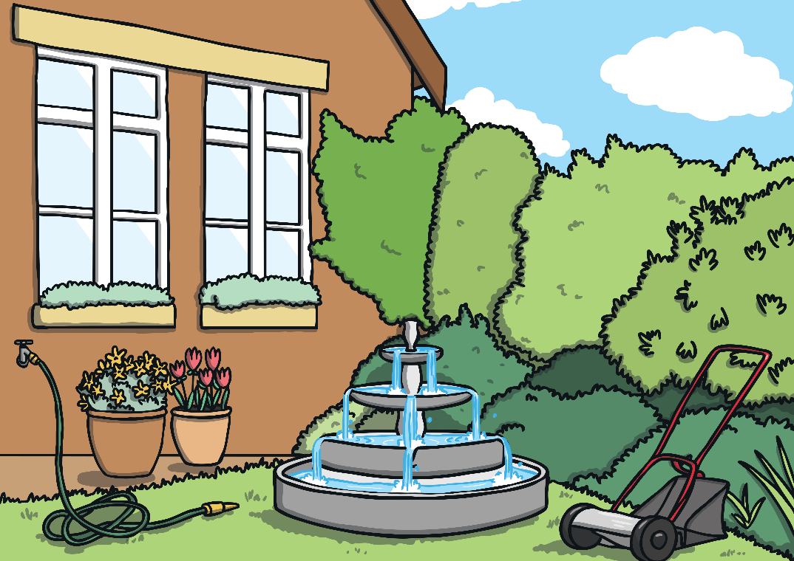

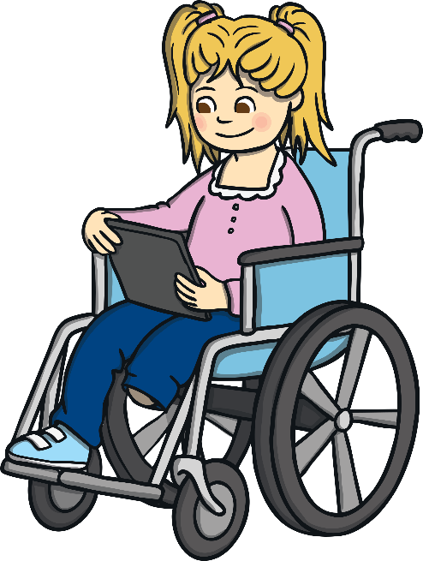

My name is .

My teacher is .

I am years old.

I go to School.

There is a virus called the Coronavirus which is spreading across the country. Coronavirus spreads quickly and makes people sick and this is why my school is shut as the teachers want the children to stay at home and be safe. I also need to be safe when going outside.

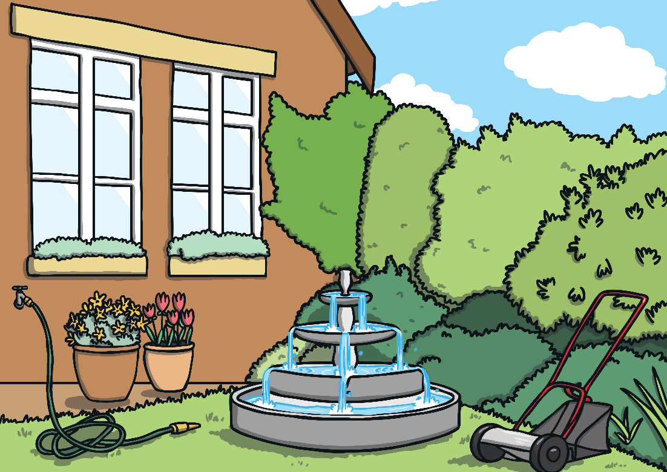

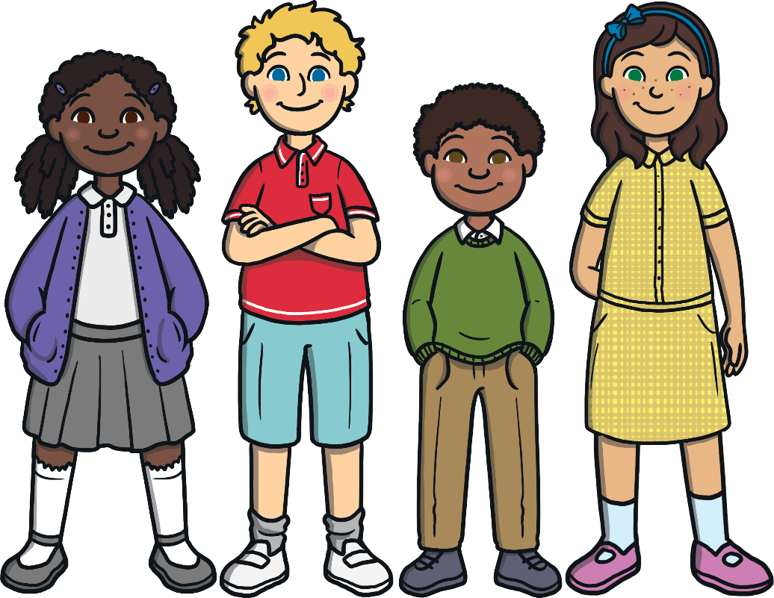

When I go out, if I see other people, I need to remember to keep a safe distance (2 metres) between myself and the other person. This is a good thing to do and will keep me safe.

I can go out with my parents/carers (delete as appropriate) once a day for a short walk as part of exercising. I cannot go with friends; it can only be with the people that I live with. This will keep me safe.

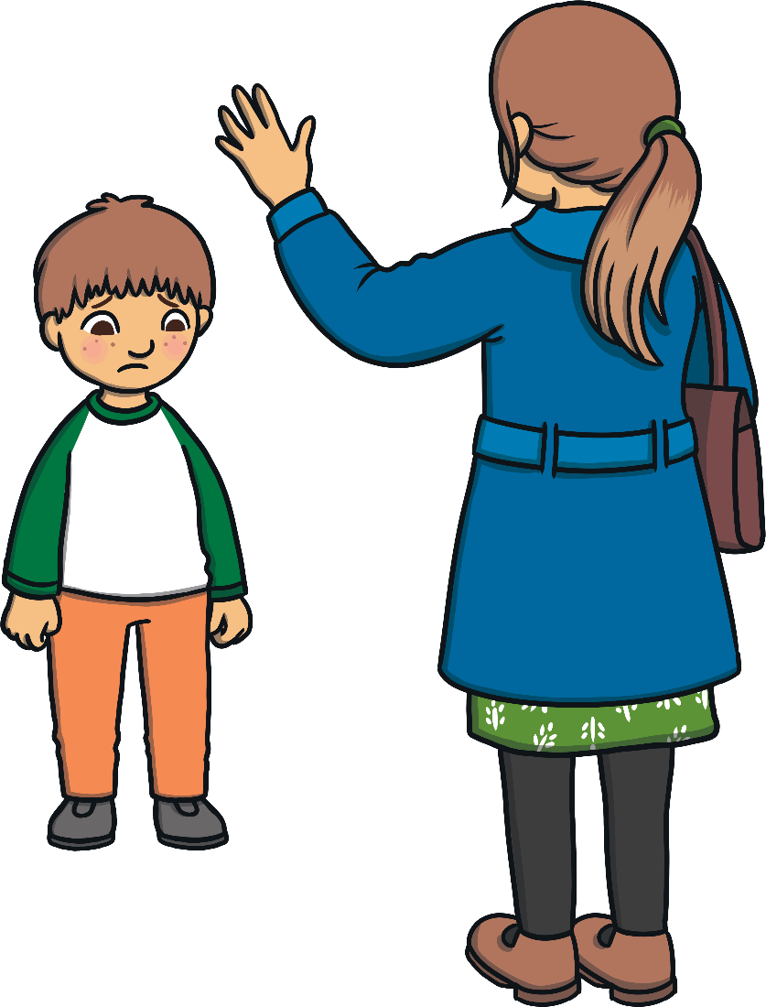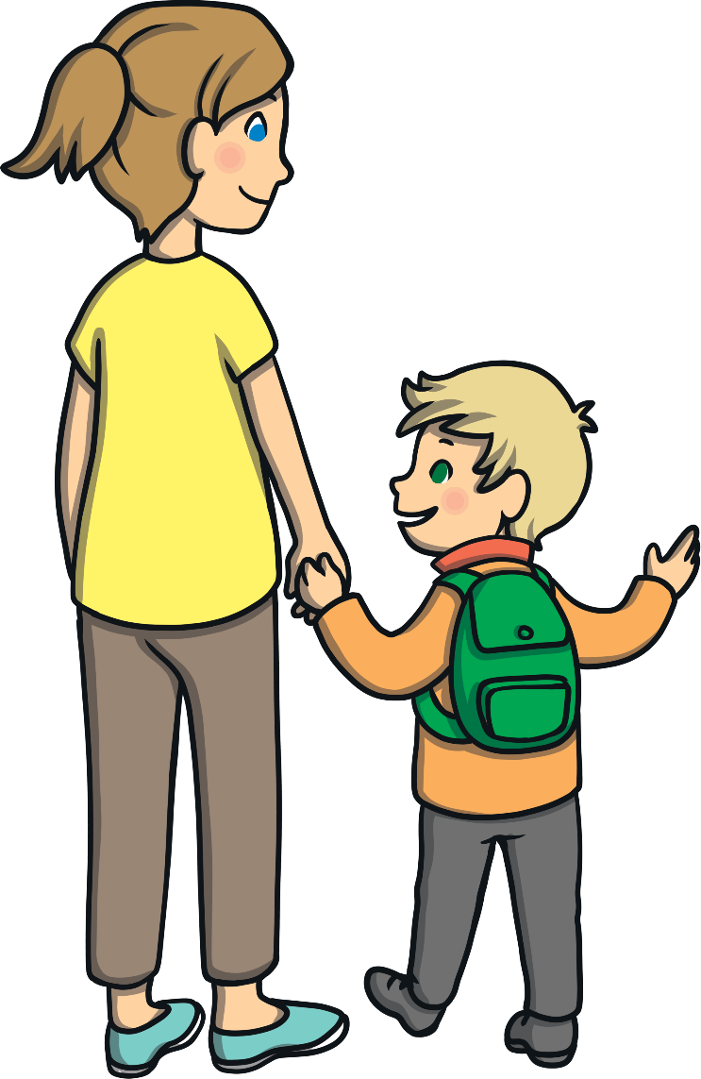

I will try and remember that I can go out for a walk once a day with my family, that I need to keep a safe distance from other people and that I must wash my hands when I get home.

When I get home, I must wash my hands straight away. This will make them clean. Washing my hands is a good thing to do and will keep me safe.

